4th October 2023

The Chairman and Members of the Planning Committee
Tandridge District Council
8 Station Road East
Oxted RH8 0BR

Dear Ian, Claire and Members of the Planning Committee,
Planning Application 2023/938; demolition of the existing building and erection of a new 64 bedroom care home; the Grasshopper Inn, Westerham Road, Westerham, Surrey, TN16 2EU
Thank you for the opportunity to comment on this application. Limpsfield Parish abuts the site and development on the site will have a significant impact on the character of the area and the approach to Limpsfield Village.
We recognise that the current buildings have fallen into disrepair and there is a need for positive proposals to bring the site into effective use. However, we have significant reservations about the current proposals.
Over the years, the Grasshopper Inn has been extended and altered on a number of occasions. However, it has retained a distinctive character, a character which has warranted its inclusion as a non-designated heritage asset in Tandridge District Council’s list of buildings of character. The most recent planning permission was granted in 2017. This proposal, whilst increasing the amount of development on the site, would have retained the overall character of the buildings and site and helped to secure the future of the business.
The current proposal, however, results in the loss of the remaining parts of the building and construction of a large and bulky building, a building and design which might be appropriate in an urban location but is wholly inappropriate on this sensitive site in the Green Belt and the AONB.
Against this background, we would support the representations made by Tatsfield Parish Council and object to the development on the grounds that:
- It would involve the loss of a building, which, whilst not a designated heritage asset, is on the local list of buildings of character and contributes significantly to the character of the area
- It would create a development with a bulk, form and design which would be detrimental to the character of the AONB in this prominent location close to the A25
- It would constitute inappropriate development in the Green Belt and the very special circumstances which applied when the previous permission was granted no longer exist.
We also note that part of the existing site is excluded from the application. We would ask for clarification as to the future use of this land. Further proposals should incorporate the land into the site or agreement should be reached for it to be permanently landscaped.
Yours sincerely,
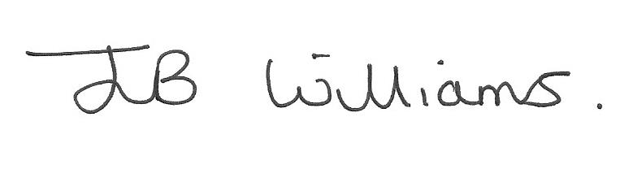
Jenny Williams, Chair, Limpsfield Parish Council Planning Committee

