LIMPSFIELD PARISH COUNCIL - GRANT AID (S137) APPLICATION FORM

 | Please complete this form in block capitals
- Name and address of the organisation requesting a grant | LIMPSFIELD VILLAGE STORES ASSOCIATION (LVSA) t/a LIMPSFIELD MEMORIAL STORES  HIGH STREET  LIMPSFIELD  RH8 0DT
- Contact name (who has authority to act on behalf of your organisation) | ALISON EARNSHAW  (CHAIR OF MANAGEMENT COMMITTEE)  alison.earnshaw@icloud.com
- Amount requested | £2,500 + 10% contingency
- Purpose(s) for which the grant will be used | ALTERATIONS TO THE POST OFFICE AREA WITHIN THE SHOP  PLEASE SEE ATTACHED
- Please specify how this will benefit the parish and/or the parishioners of Limpsfield | PLEASE SEE ATTACHED
- Have you requested, or are you receiving funding from other sources? (if yes, please provide amount and funder(s) details) | YES  £500 RECEIVED FROM TVA TO HELP WITH MARKETING AND UPDATING OUR WEBSITE
- Signed | Alison Earnshaw
- Dated | 30th January 2024

Background

- Limpsfield Village Stores Association (LVSA) is known locally as Limpsfield Memorial Stores and Post Office. It is a not-for-profit community shop and Post Office run by the community for the community, serving Limpsfield village in Surrey and surrounding areas.
- The shop was established in 1999 by a volunteer membership with our Certificate of Incorporation (13.04.1999) being under the Industrial and Provident Societies Act 1965. It was initially funded by loans and gifts from the community, all of which have now been paid back.
- We are predominantly a volunteer-run organisation with 6 volunteer committee members, and around 40 volunteers who serve in the shop and the Post Office. Local involvement is strong. Many of our current customers have been active volunteers over the last 24 years, and we now have a new generation of volunteers. Many of our volunteers and customers are ‘members’ of the LVSA (cost £10) and this entitles them to vote at the AGM.
- We support the Duke of Edinburgh Scheme and have students from the local schools volunteering.
- LVSA employs one full time Manager who is responsible for both the shop and PO, a Morning Assistant and a Sunday Morning Assistant. Over recent years, sixth formers from local schools have filled the Sunday Assistant role.
- We predominantly serve local customers but also have considerable passing trade. The shop provides a friendly meeting place and much needed social contact for many of our customers who live on their own.
- During Covid, the shop and PO remained open and were invaluable to local people. Grocery deliveries were arranged for some people who were isolating or vulnerable.
- We sell newspapers, groceries, bread, cakes, fruit and vegetables and some specialist / gift items. As far as possible, we source our products from local suppliers (eg local honey, eggs, bread, chilled meats, turkeys) whilst also ensuring a broad product range to meet local demand.
- The Post Office has two Royal Mail collections a day, a Parcelforce collection, and provides essential banking services (including foreign currency orders) now that the banks and other local Post Offices have closed. Mail currently accounts for around 73% of our post office income and banking 21%.
- Customers regularly tell us how grateful they are to have Post Office and banking facilities locally, and they appreciate the personal friendly service.

Details for funding application

What we would like to do

This year, we will be celebrating our 25th year of trading and we would like to mark this anniversary by carrying out improvements within the shop, predominantly by extending the post office area to create a new working space for our Manager.

Reasons
- Post office income increased by 6.5% in 2022/23 and is estimated to increase by circa 6% this financial year. This represents growth of over 10% since 2019/2020 when income was paid to us on a fixed rate by Post Office Ltd. Since then, payments have become incentivised, and we now receive income based on the goods and services we sell. (See Appendix 1 and 2 below). The post office business is growing, currently representing around 36-40% of our total gross income (See Appendix 3) and, as a result, we require more space for incoming/outgoing parcels so that they are not left on the shop floor which could be a Health and Safety hazard and contravene GDPR regulations.
The increased post office business is due to us:
  - offering increased banking services
  - being a hub to replace local banks and post offices that have closed during the past couple of years
  - taking on extra services to serve the local community e.g. Amazon and (soon) Evri and DPD returns and collections
- It is some time since we carried out improvements in the store and we recognise that the shop would benefit from some refurbishment. However, our profit and loss accounts over the last few years have not allowed us to make any further investments in the business.
- For this current period though our accounts are showing good growth compared to previous years and we have already committed funds to buy a new upright freezer to replace the old leaking, inefficient one. We have also made arrangements for the inside of the shop to be painted throughout and this will be happening at the end of January.
- Improvements this year would mark our 25th anniversary
- The Manager currently works from a desk in a very small space which is also used for hanging coats and as a kitchen area. It is right next to the toilet which does not make for a very pleasant working environment! It also involves regular logistical problems when volunteers/staff want to use the toilet, hang up their coat or make a drink because only one person can access the area at any one time and the Manager is then forced to move away from her desk

The Proposed Plan (to be completed by the end of April 2024)
- Extend the wall from the glass corner of the PO across the wall to the shelving units; bring the PO door and frame forward in line with the glass corner of the PO; fit a non-opening window into the new wall. (We are currently liaising with Post Office Ltd to ensure we meet any specific conditions.)
- Inside the new space, fit a new desk and cupboard; on the shop side of the new wall, add shelving and/or display racks
- Re-decorate area

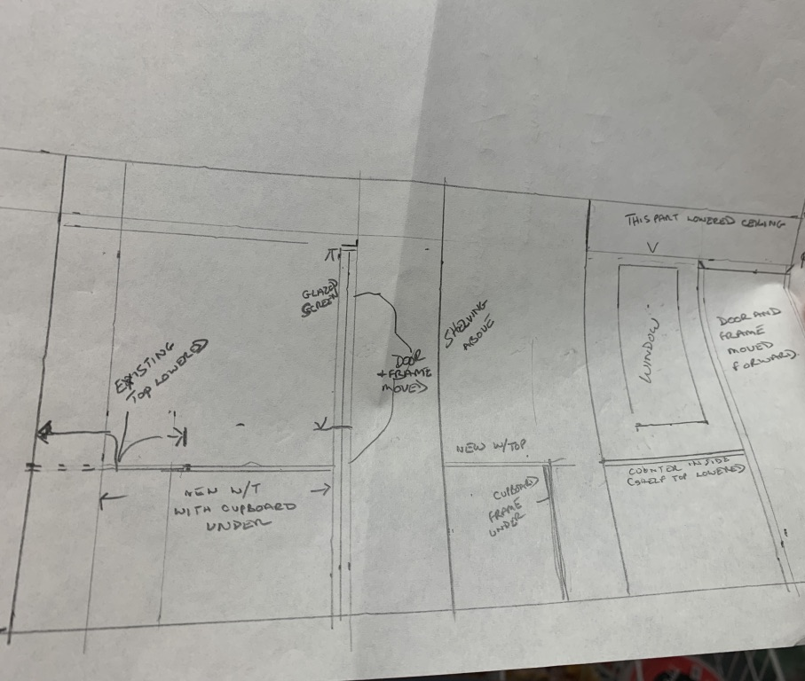
Sketch of proposed changes

Internal view External view

Estimated Cost
- We estimate that the cost of carrying out the above alterations, adding shelves and racks on the new shop-side wall and also decorating the altered area would be approximately £5,000 inc. VAT.
- We have a quote of £3,920 inclusive of all materials, electrics, fitting worktop, building a cupboard and moving shelves. It does not include any shelving or racks on the new shop side wall or decorating costs for the extension or the provision of an air conditioning unit. We have estimated this amount to be £1,000, hence a total estimate of £5,000.

Please note the quote was received towards the end of 2023 so the amount may need to be revised. Subject to Post Office Ltd guidelines, we may also need to upgrade our current post office door and lock which will add to the total.
- While we do have reserves held in a savings account, our accountant has advised us that our current level of savings meets the recommended 6-8 month buffer amount to be held for covering staff and overhead costs in case of emergencies. We are therefore applying for £2,500 from LPC which would cover 50% of the alterations, the remainder to be covered by LVSA profits.

Benefits
- A safer and smarter/more attractive shop and post office environment which would hopefully lead to increased business
- an improved shopping experience for our customers and better working environment for our staff and volunteers
- Some revised merchandising of stock to make it easier for customers to make their purchases
- A more appropriate working area for our Manager
- A layout that meets the changing requirements of our community shop ie. improved storage for parcels in order to meet increased demand, H&S requirements and GDPR regulations
- A lasting reminder of our 25th anniversary.

Appendix 1 – Limpsfield Memorial Stores Post Office income 2019 to present

-3.4%
+1.1%
+6.5%

 |  | 2019/2020 | £22,494.40
 |  | 2020/2021 | £21,728.53 | -3.4%
 |  | 2021/2022 | £21,972.54 | 1.1%
 |  | 2022/2023 | £23,402.02 | 6.5%
 |  | 2023/2024 Est | £24,790.76 | 5.9%

NB:
- 2019/20 income paid to us by Post Office Ltd was at a fixed rate. From 2020/21 onwards, post office income is incentivised based on what we sell.
- The 2022/23 income figure has been adjusted to take out a retrospective VAT payment that was made during the period.

Appendix 2 – Limpsfield Memorial Stores Post Office Transactions 2020 to end 2023

Appendix 3 – Limpsfield Memorial Stores: Shop Gross Profit vs Post Office Income

The post office accounts for approximately 36-40% of the total business .

(when gross shop profit is compared with the income received from the post office - before any expenses are deducted. As shop gross profit has grown this year, the post office contribution is currently around 36%.)

NB. The post office income in 2022/23 was affected by a retrospective VAT payment that was paid during this financial year.

